Task – 1: Creating a storage account
Step 1: Searching for storage account in search bar and accessing create screen, and finally filling the basic details such as the resource group, name and redundancy. Redundancy means storing multiple copies of your data to ensure data availability and durability, even in the face of failures or disasters. Here I’ve chosen the LRS option which states that a 3 copies of the data are to be made and kept in the same datacenter.
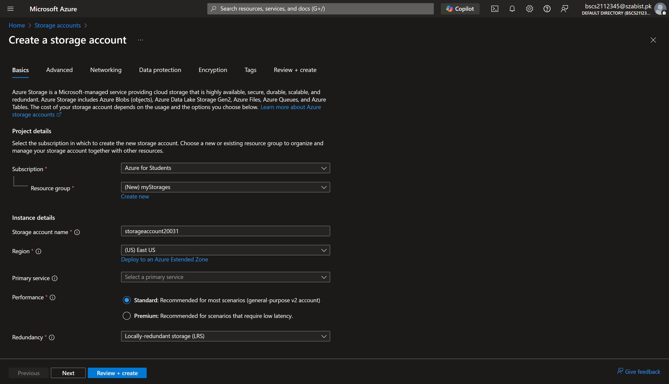

Step 2: Displaying the complete configuration of the storage account after validation pass
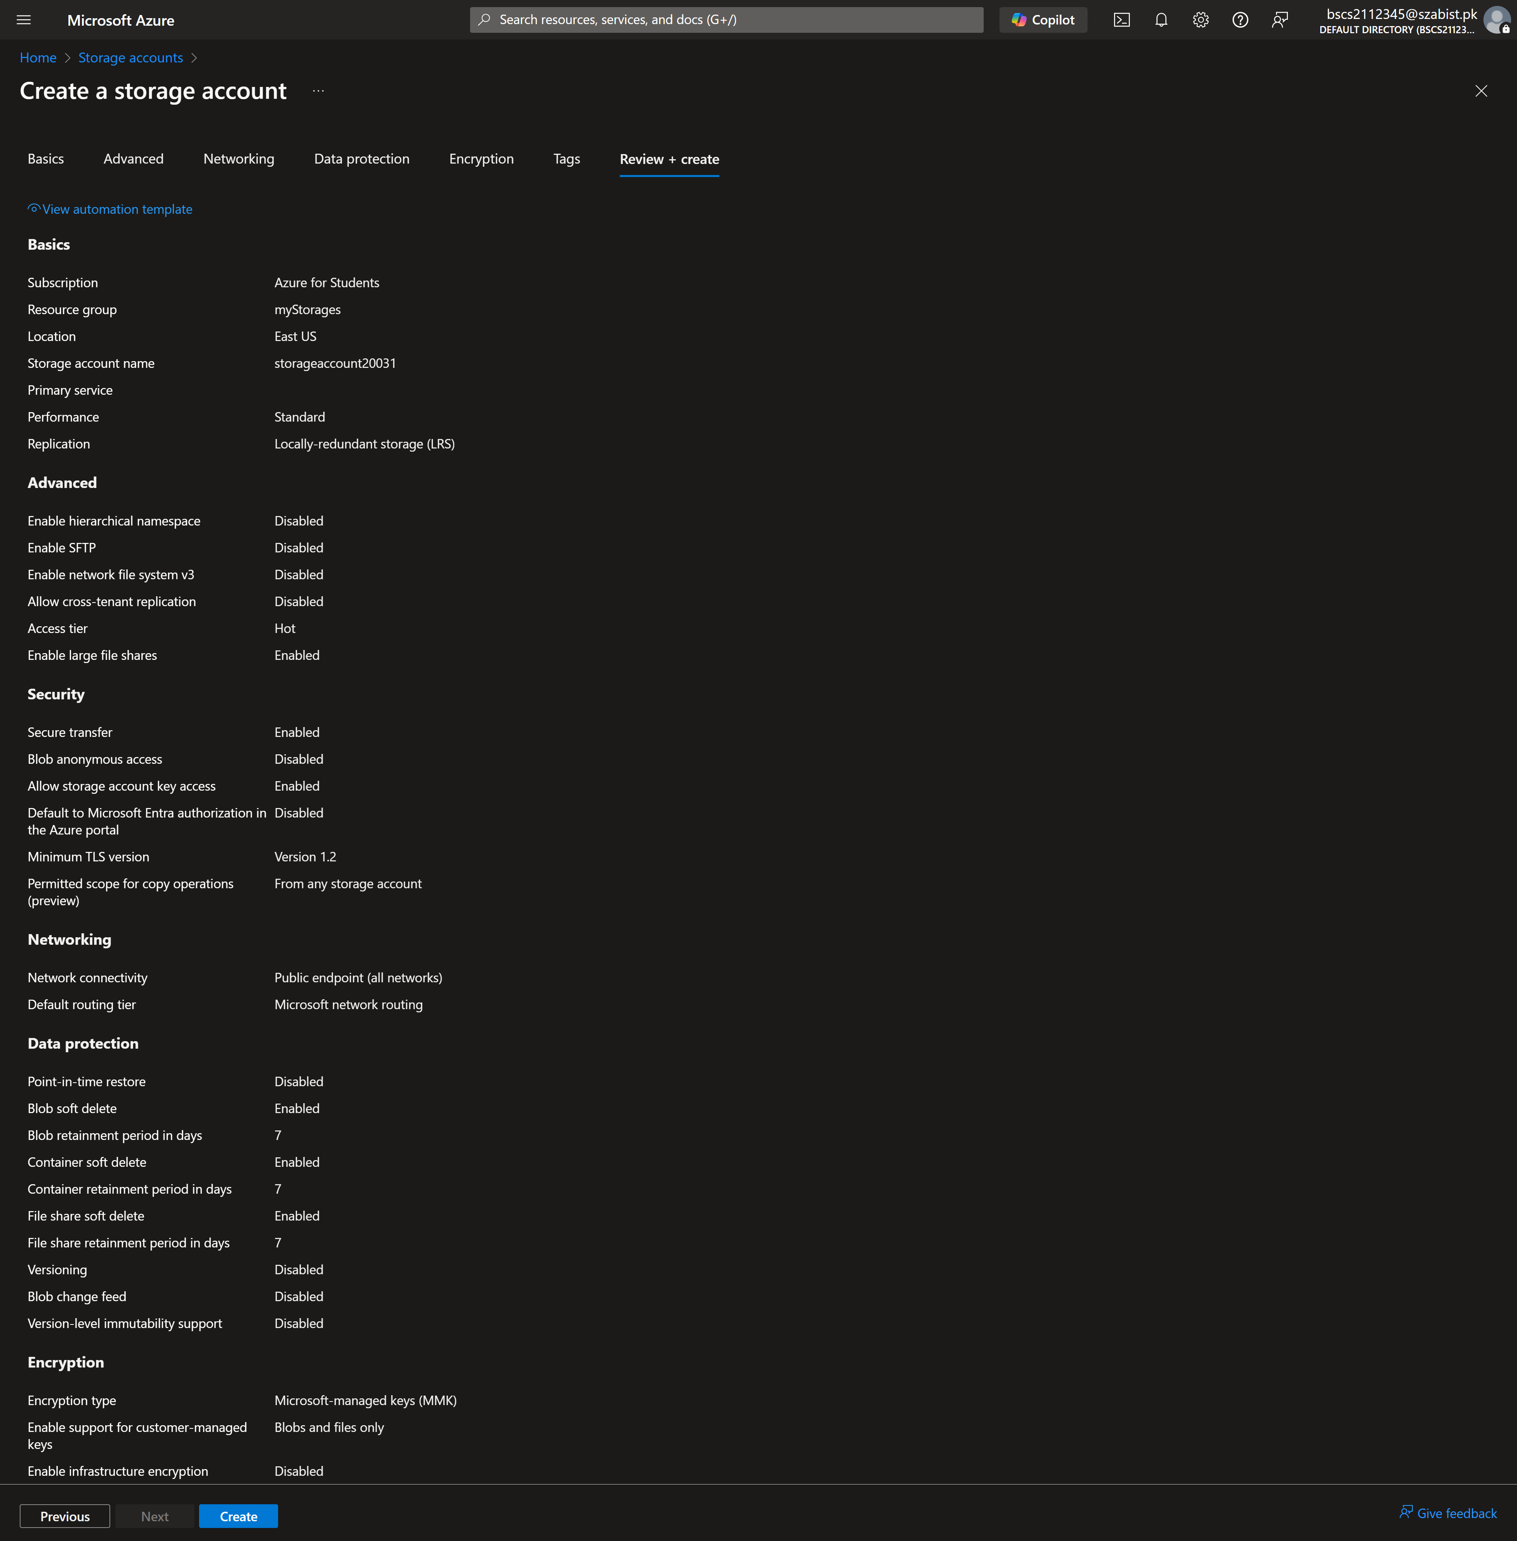

Step 3: Displaying the successful deployment/creation of the storage account.
